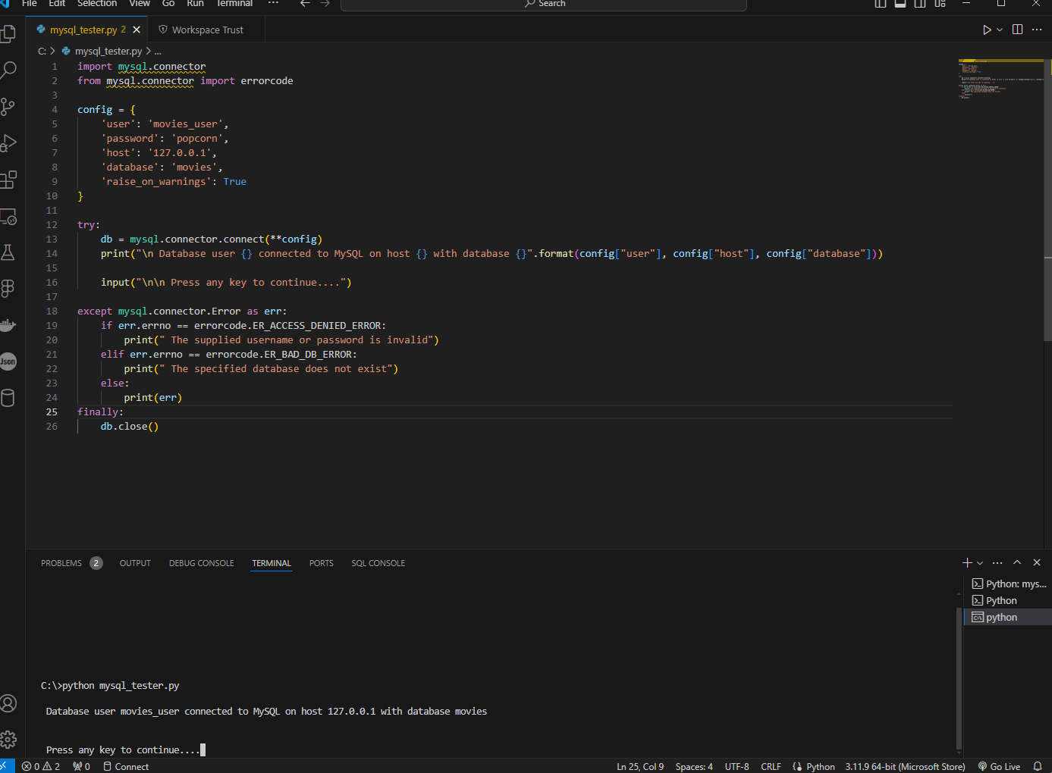

https://github.com/Ken-Smit/csd-310